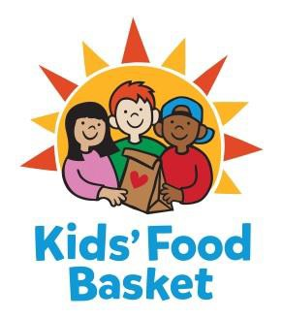
JOB DESCRIPTION
Grants Intern

Fall 2017
10 hours weekly
Reports to: Liz Washington, Grants Specialist

For fifteen years, Kids' Food Basket has been a force for attacking childhood hunger to help young people learn and live well. One in five Michigan children struggles with hunger, robbing them of their energy, health and dignity. A lack of consistent, nutritious food limits cognitive development, leaving kids unable to concentrate in school. Kids' Food Basket is playing a critical role in ending the cycle of poverty by helping kids get the nourishment they need to succeed in school and life.

Childhood hunger is a community problem, with a community solution. Over the past decade, we've grown from serving 125 kids at 2 school sites in Grand Rapids, to now serving nearly 7,500 kids between 36 schools in Grand Rapids, three schools in Muskegon and three schools in Holland. All programs are charitably funded by their individual communities, and made possible through the help of over 250 volunteers every day!

Kids’ Food Basket provides equal employment opportunities (EEO) to all employees and applicants for employment without regard to race, color, religion, gender, sexual orientation, gender identity or expression, national origin, age, marital status, height, weight, genetic information, qualified disability, or veteran status. In addition to federal law requirements, Kids’ Food Basket complies with applicable state and local laws governing nondiscrimination in employment in every location in which the organization has facilities.

Internship Duties:
- Assist in organizing, maintaining, and recording grant communications; research and creation of organization profiles; administrative grant management duties and grant fulfillment opportunities; and data entry support.

Skills and Qualifications
- Bachelor degree in progress.
- Can work independently as well as collaboratively.
- Excellent written and verbal communication skills.
- Organized with the ability to work in a fast paced, ever changing work environment.

- Possesses skills in project and time management.
- Well versed in computer programs (Microsoft Office required).
- Demonstrate the ability to solve problems, analyze systems and data, and make suggestions for improvement.

Level I | Part-time Internship with Stipend or College Credit (Prior approval from intern’s school needed for College Credit)
  - 150 hours a semester = $599 stipend or approved College Credit.
  - Intern may choose to receive this payment at the end of their 150 hours or receive two payments of $299.50, with one payment halfway through their internship and the last payment at the culmination of their internship. If chosen, the stipend is provided for non-reimbursed expenses incurred by intern, such as fuel, mileage, parking fees, etc.

Send cover letter and résumé via email to: Liz Washington at lizw@kidsfoodbasket.org Applications will be reviewed as they are received. (NO CALLS PLEASE)

