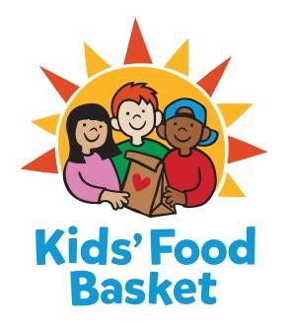
JOB DESCRIPTION
Development Intern

Fall 2017
10 hours weekly
Reports to: Sarah Ramírez, Stewardship and Special Projects Assistant

For 14 years, Kids' Food Basket has been a force for attacking childhood hunger to help young people learn and live well. One in four Michigan children struggles with hunger, robbing them of their energy, health and dignity. A lack of consistent, nutritious food limits cognitive development, leaving kids unable to concentrate in school. Kids' Food Basket is playing a critical role in ending the cycle of poverty by helping kids get the nourishment they need to succeed in school and life.

Childhood hunger is a community problem, with a community solution. Over the past decade, we've grown from serving 125 kids at 2 school sites in Grand Rapids, to now serving over 7,500 kids between 34 schools in Grand Rapids, three schools in Muskegon and two schools in Holland. All programs are charitably funded by their individual communities, and made possible through the help of over 200 volunteers every day!

Kids’ Food Basket provides equal employment opportunities (EEO) to all employees and applicants for employment without regard to race, color, religion, gender, sexual orientation, gender identity or expression, national origin, age, marital status, height, weight, genetic information, qualified disability, or veteran status. In addition to federal law requirements, Kids’ Food Basket complies with applicable state and local laws governing nondiscrimination in employment in every location in which the organization has facilities.

Internship Duties:
- Holistic Development Learning Experience | Working and learning the various departments within the Kids’ Food Basket organization. Your internship will include opportunities to work in Operations, interface with the Communications staff, and interact with volunteers and our Kids Helping Kids program.
- Donor Development Activities | phone call follow-ups, email correspondence, planning a fall donor engagement event
- Donor Stewardship Experience | Data entry, creation and ordering of thank you boards and thank you gifts, holiday card fulfillment and processing
- Additional administrative support | Including, but not limited to, preparing packets and outreach materials for donor meetings, preparing charitable gift receipt mailings for donors, and assisting with third party event processes.

Skills and Qualifications
- Bachelor degree in progress
- Excellent written and verbal communication skills
- Organized with the ability to work in a fast paced, ever changing work environment
- Possesses skills in project and time management
- Well versed in computer programs (Microsoft Office required)
- Can work independently as well as collaboratively

- Demonstrate the ability to solve problems, analyze systems and data, and make suggestions for improvement

Part-time Internship with Stipend or College Credit (Prior approval from intern’s school needed for College Credit)
- 150 hours a semester = $599 stipend or approved College Credit
  - Intern may choose to receive this payment at the end of their 150 hours or receive two payments of $299.50, with one payment halfway through their internship and the last payment at the culmination of their internship.

To be considered for this internship, please submit cover letter and résumé to:

Sarah Ramirez: sarah@kidsfoodbasket.org

Applications will be reviewed as they are received.

